**IMPORTANCE OF DATA VISUALIZATION**

Simplifies complex data to make decisions

**GETTING STARTED WITH TABLEAU**

1. **Connecting tables through server**

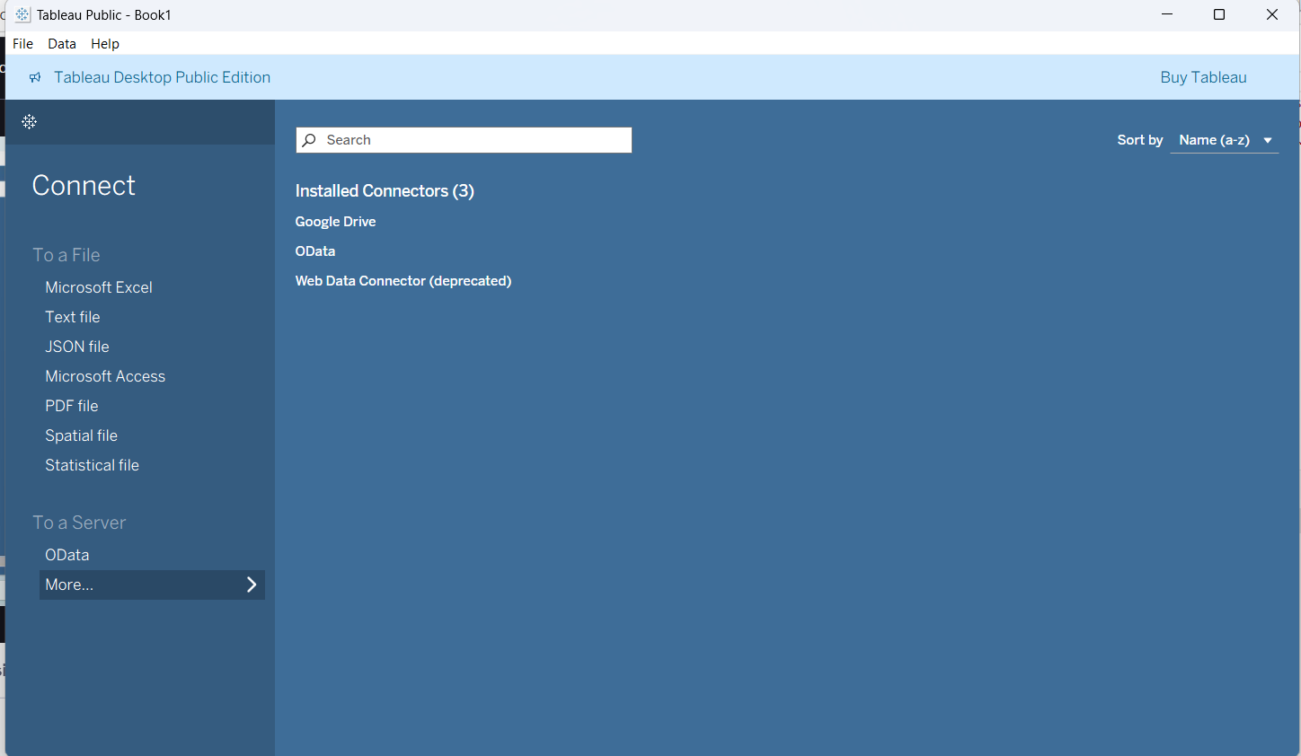

In above image more option we can find the options to take data from any existing relational

database servers.

1. **Loading excel sheet –** It can be done using To a file option, after loading it below is the screen, in row we can enter how many rows we want to load all data.

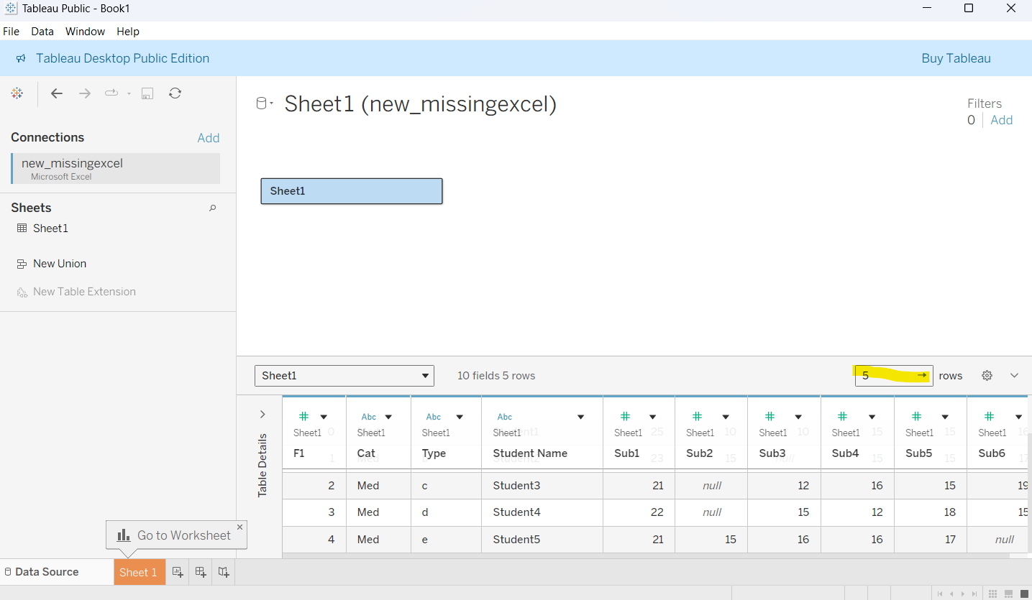

1. **Cleaning text file in work sheet –** when we load excel, csv files there a option called use data interpreter will be available that will cleans the excel sheet before loading the excel sheet into tableau.

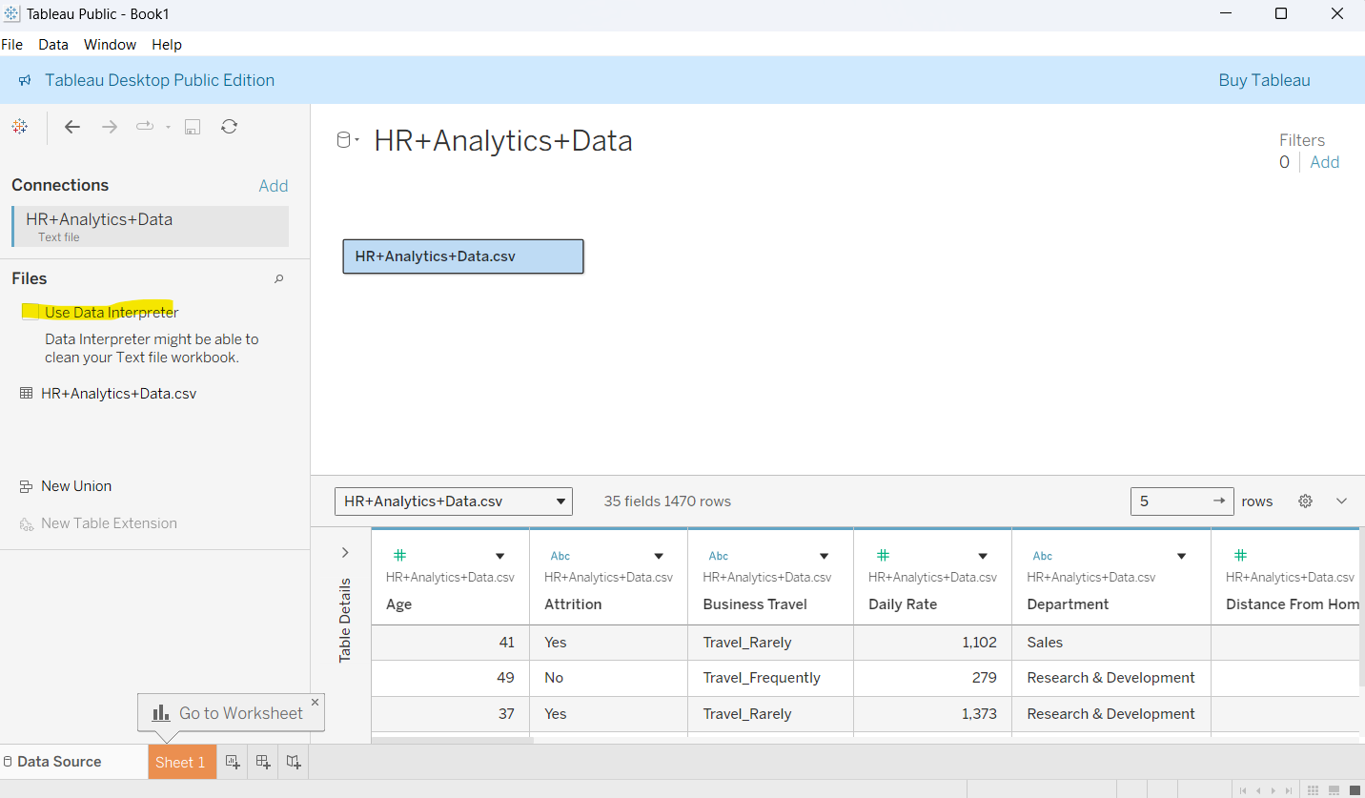

**Example:**

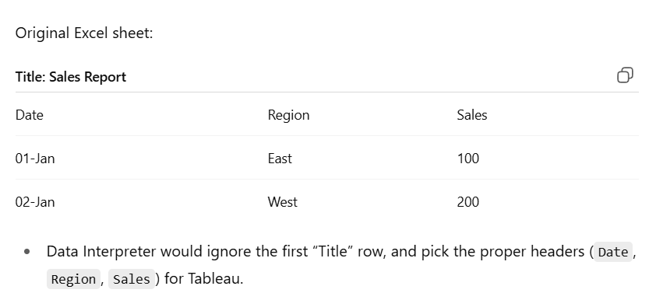

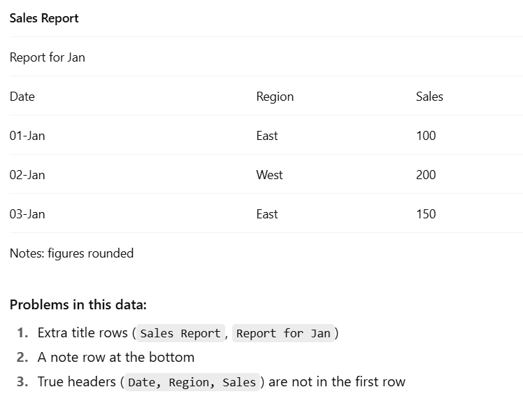

1. **Automatic generated fields –** When we load a excel file tableau has a feature to create new columns from it, in below dataset we have location so, longitude, latitude will be generated from it automatically.

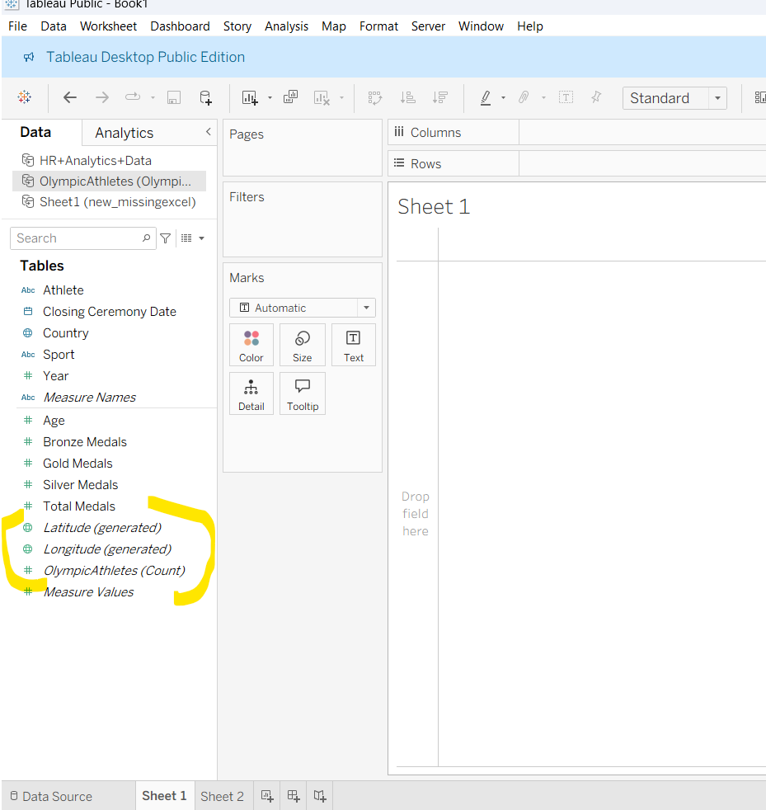

**CREATE SAMPLE DASHBOARD**

1. Load the excel sheet
2. Move to sheet option
3. Double on sheet to give title like below a pop will open. Give title click ok or apply

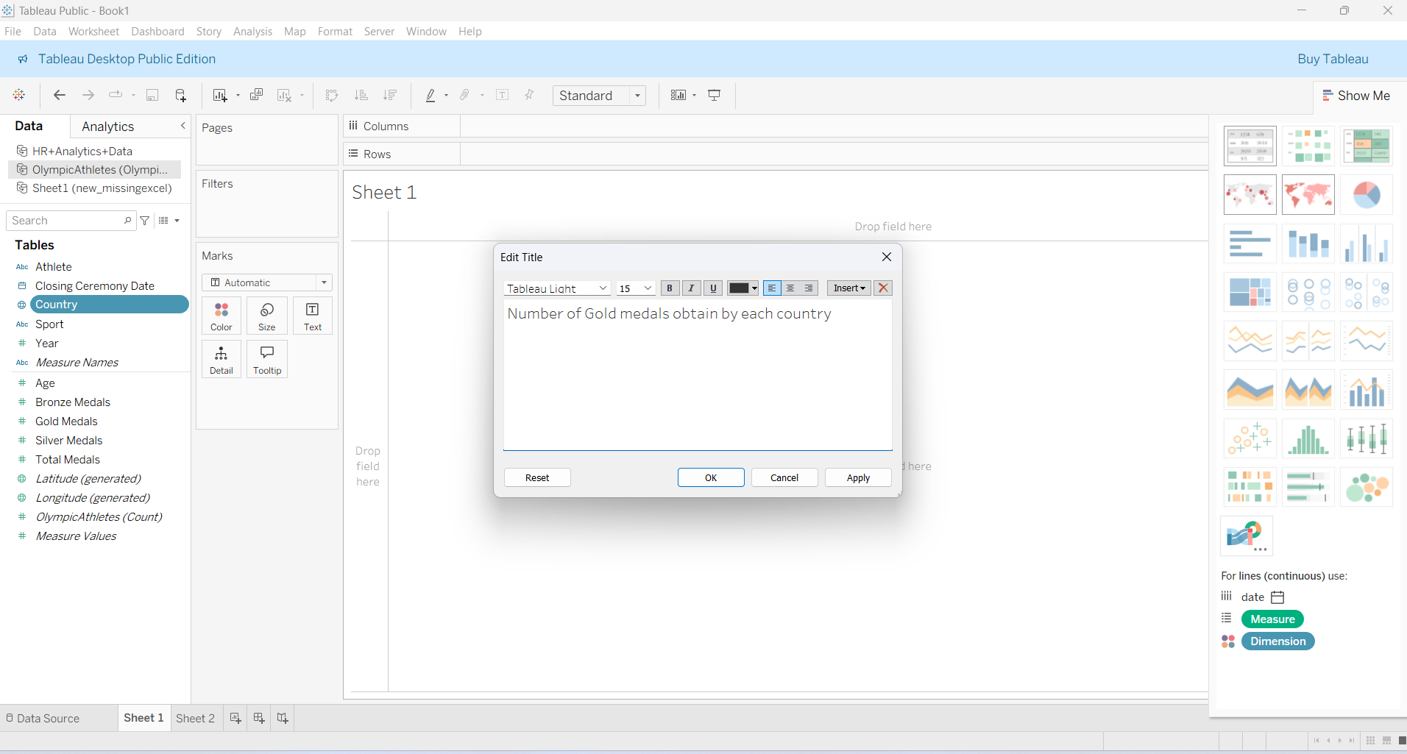

1. Drag and drop the needed columns and rows from left side to center columns like below image.

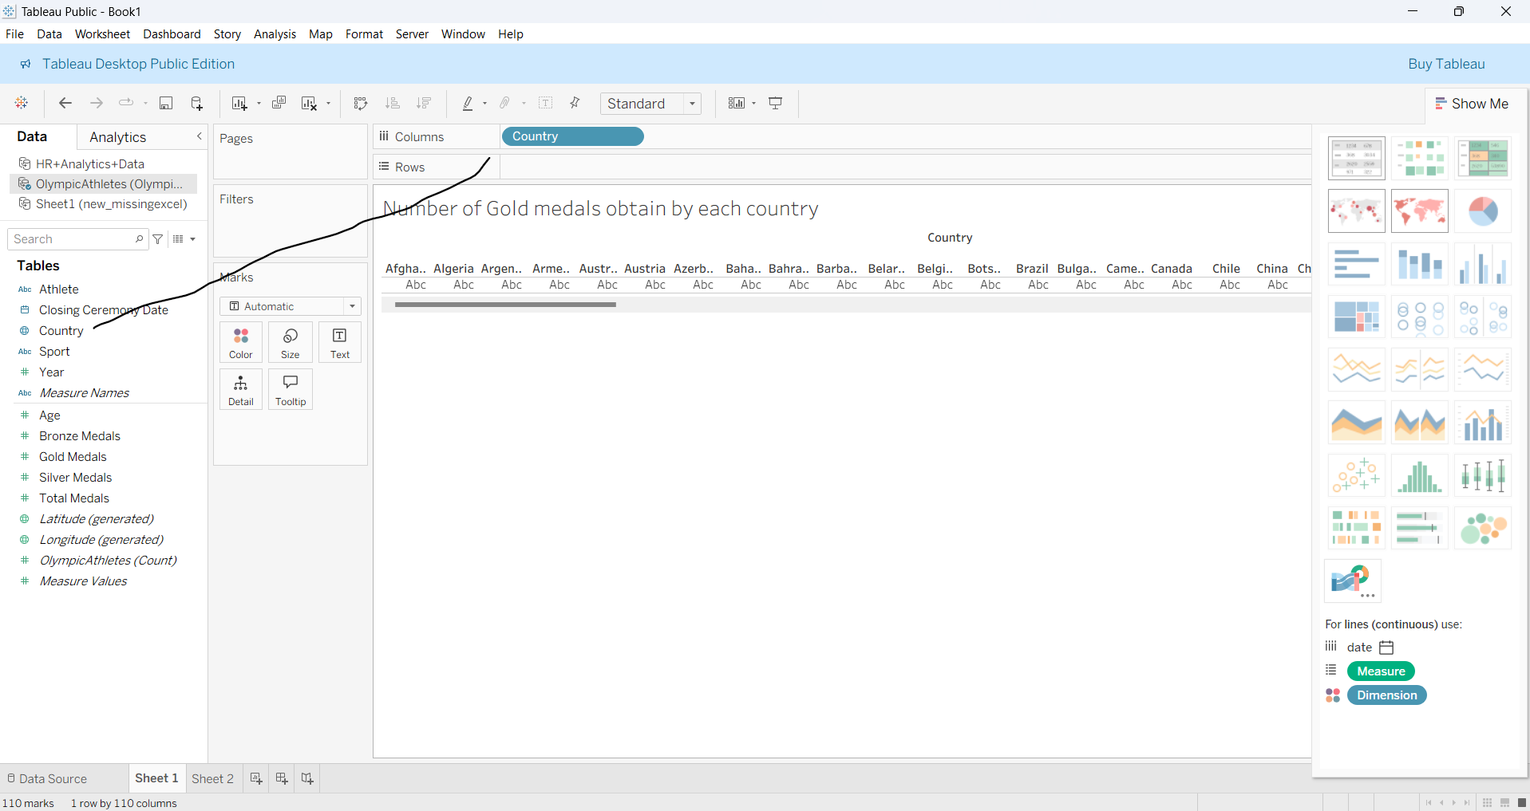

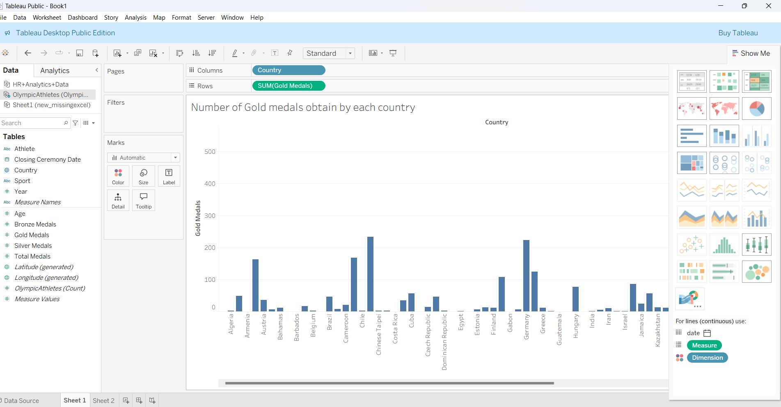

We can change any type of charts from the right corner charts

**ADDING DIFFERENT COLORS TO EACH BAR**

If we drag and drop the column we want into color then each bar will take different color like below.

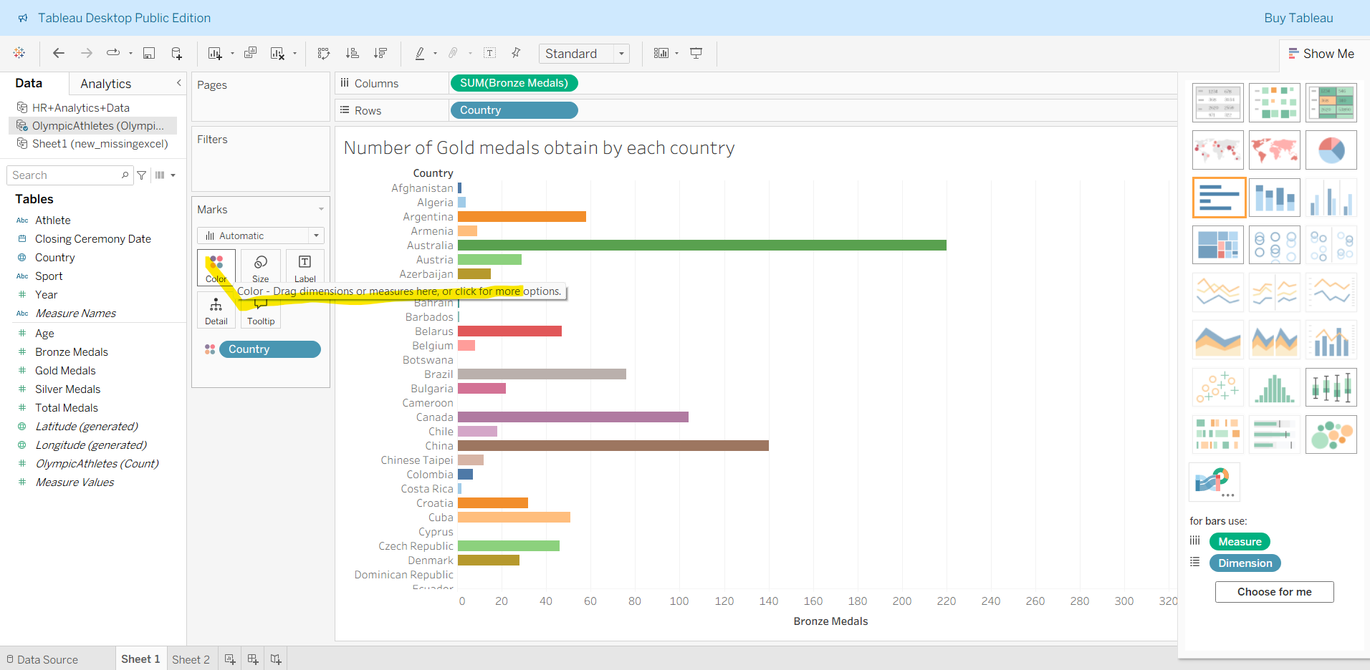

**TAKE TABLE INSTEAD OF GRAPH**

From the table option in right side we can convert our graph into table like below

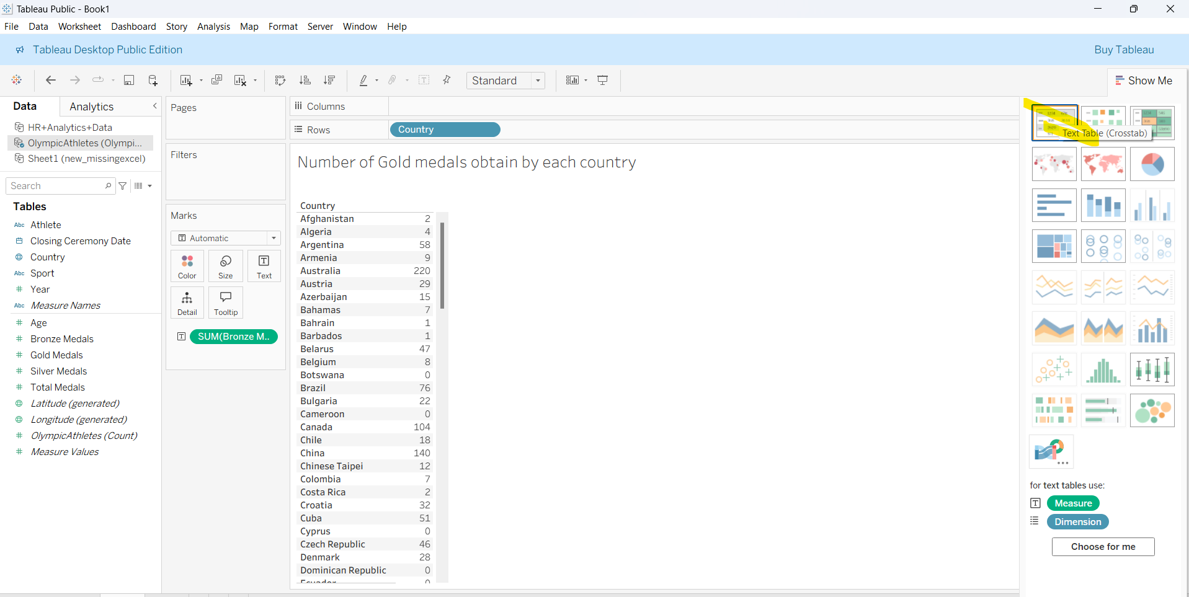

**FORMATING HEADING**

Like adding bg color to heading can be done by the below options

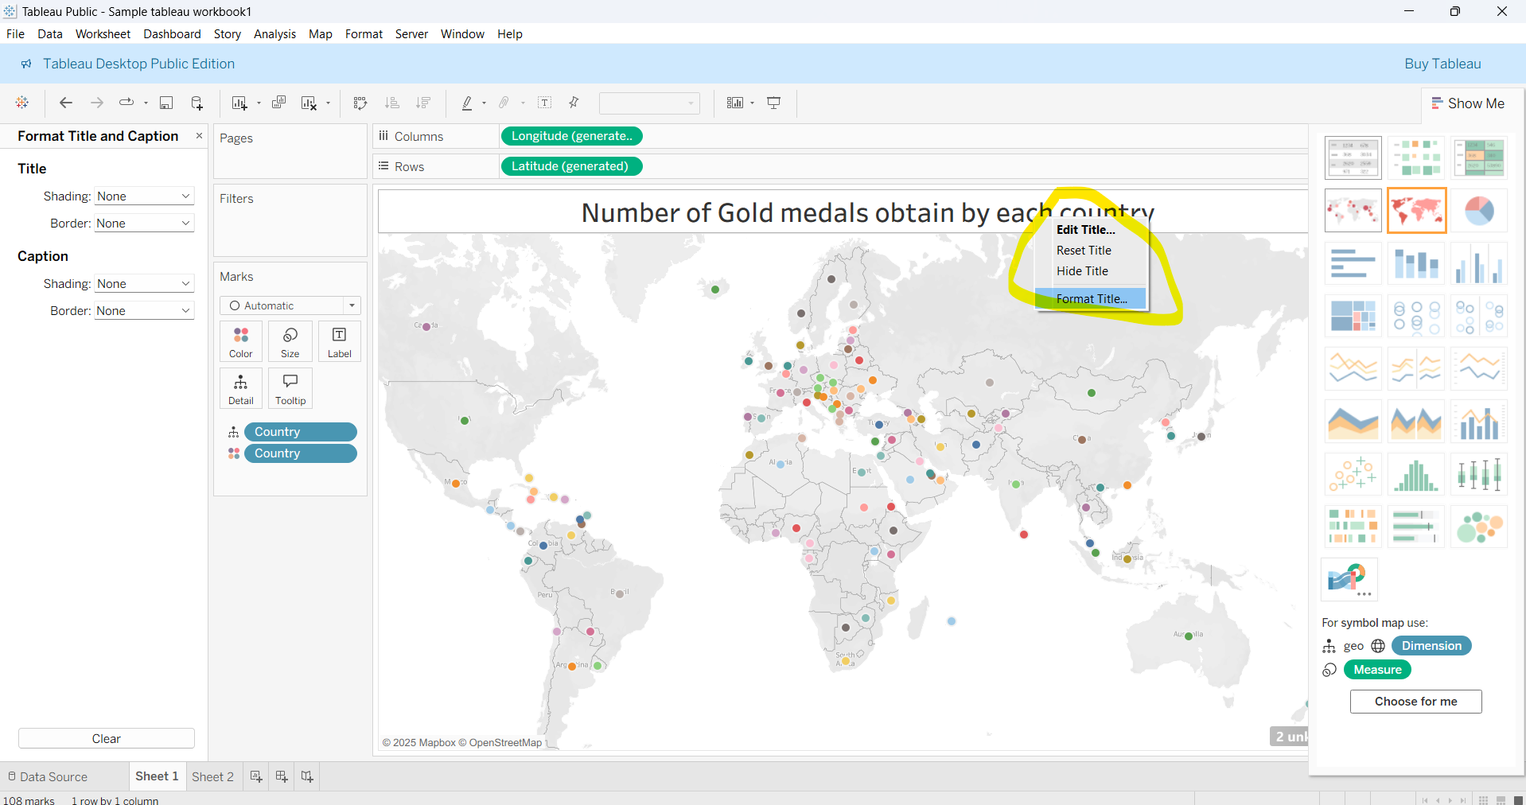

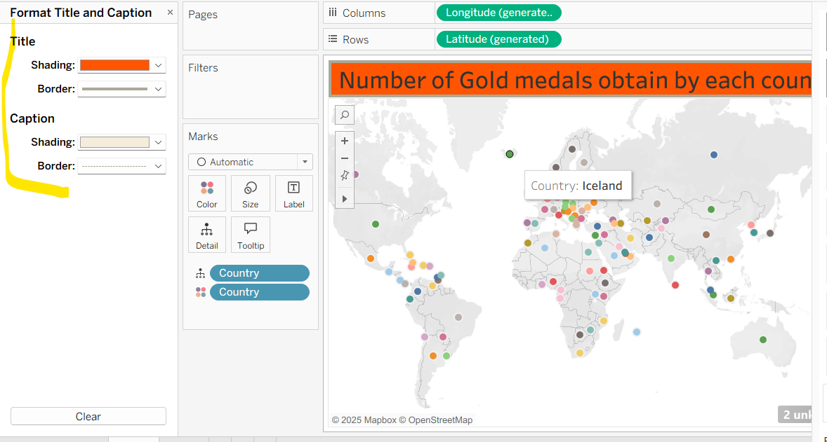

**COMBINING MULTIPLE SHEETS**

In below we have three worksheets in excel, on tableau we are going to combine this three sheets.

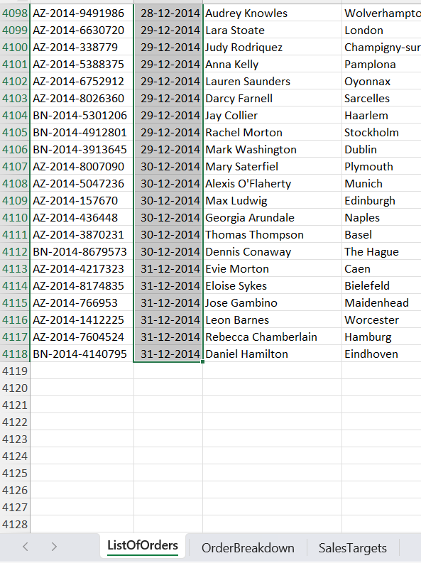

When you load the above file tableau lists all the sheets in left corner, we have drag and drop the needed to sheet to connect each sheet from left to center of the window.

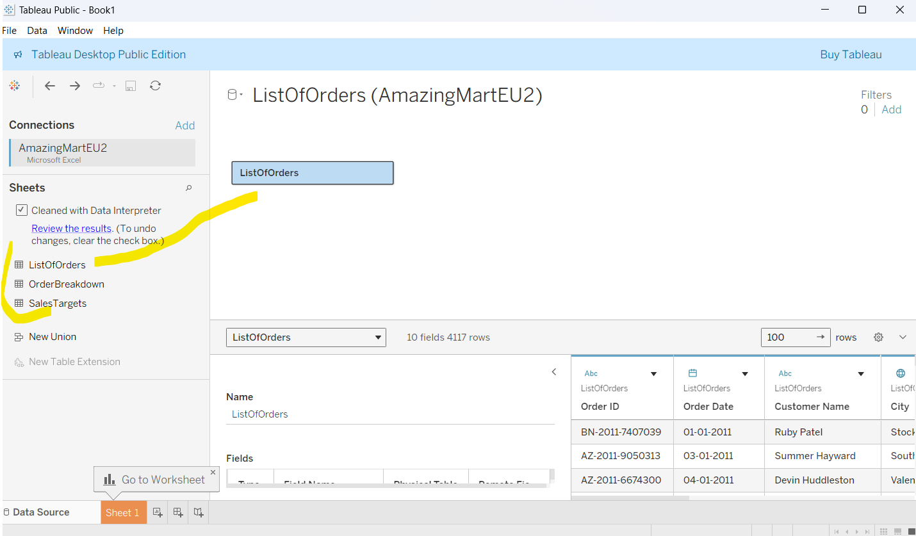

Double click on the current Drag and dropped it will seems like below screen.

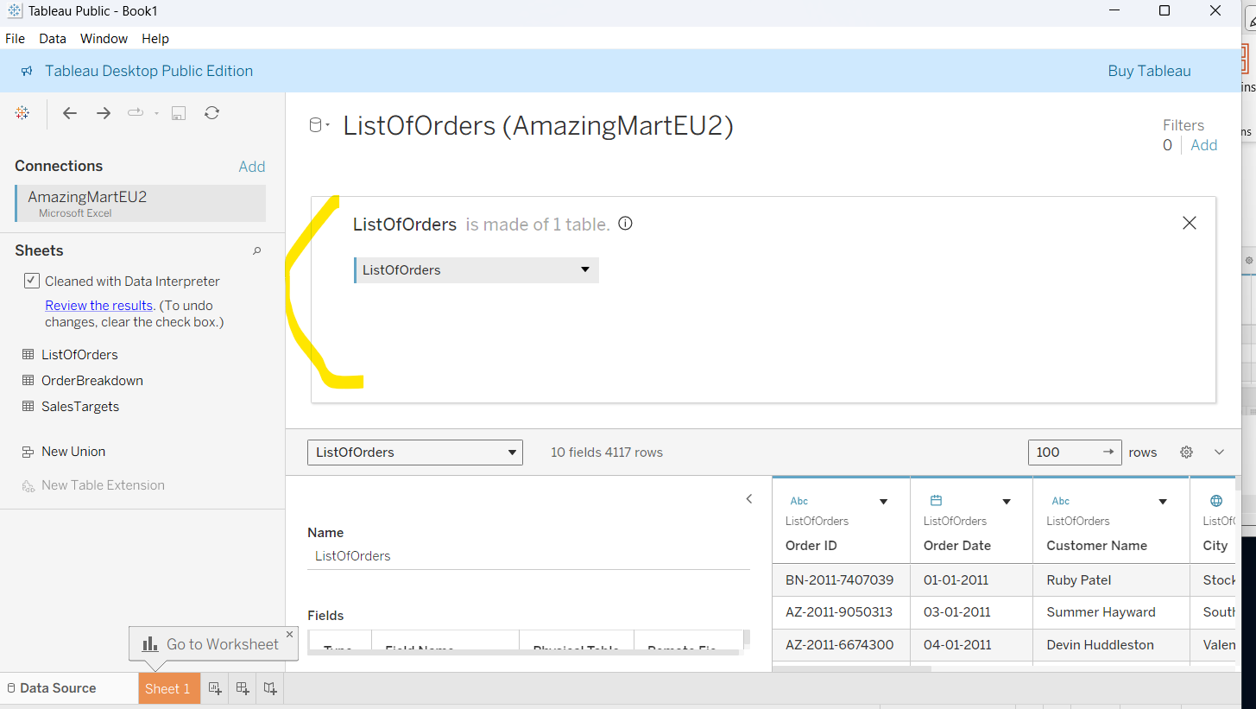

Now Drag the second sheet called Sales Target to the exact right side of the center ListOfOders sheet( then only we can able to see join options like below).

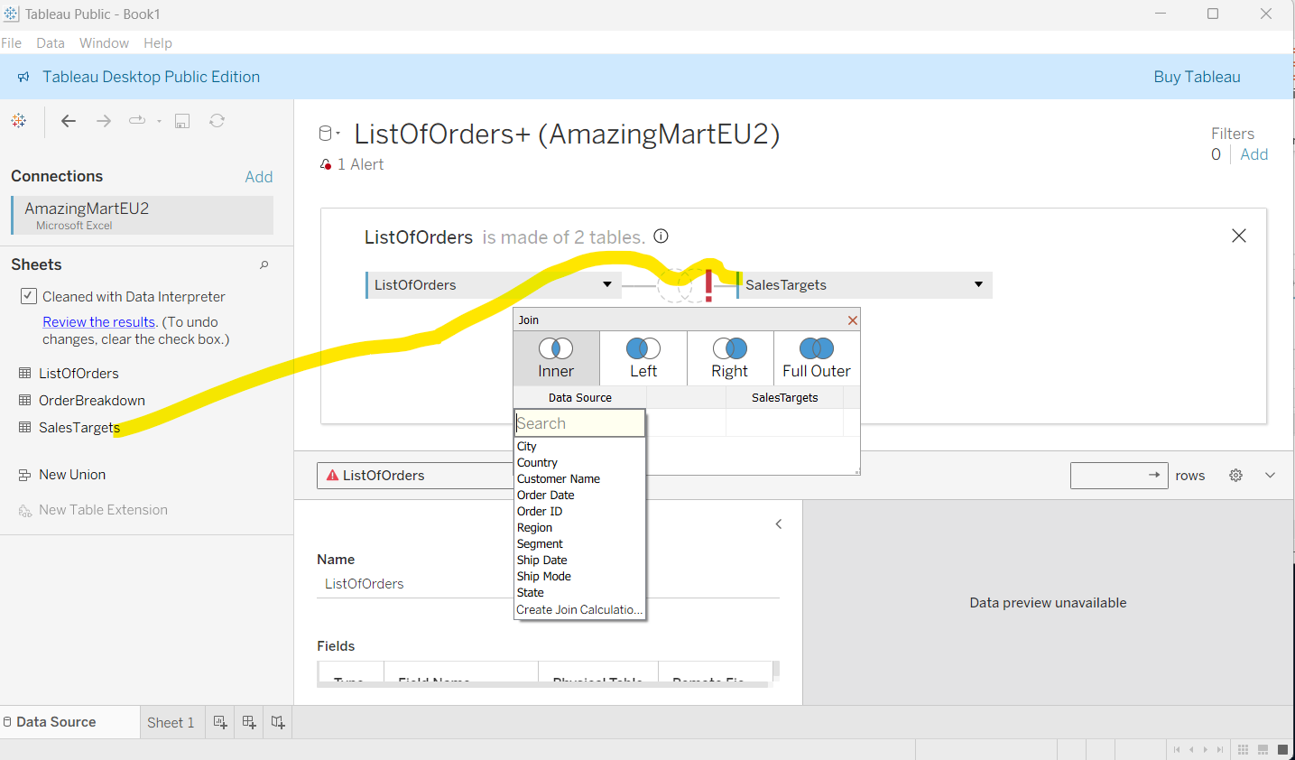

If common column doesn’t exist in both sheet the warning will appear between two sheet when we try to make join like the above screen.

If common column exist in both table the join operation will be done automatically like

below, here sheet ListOfOrder and OrderBreakdown has common column that is OrderID

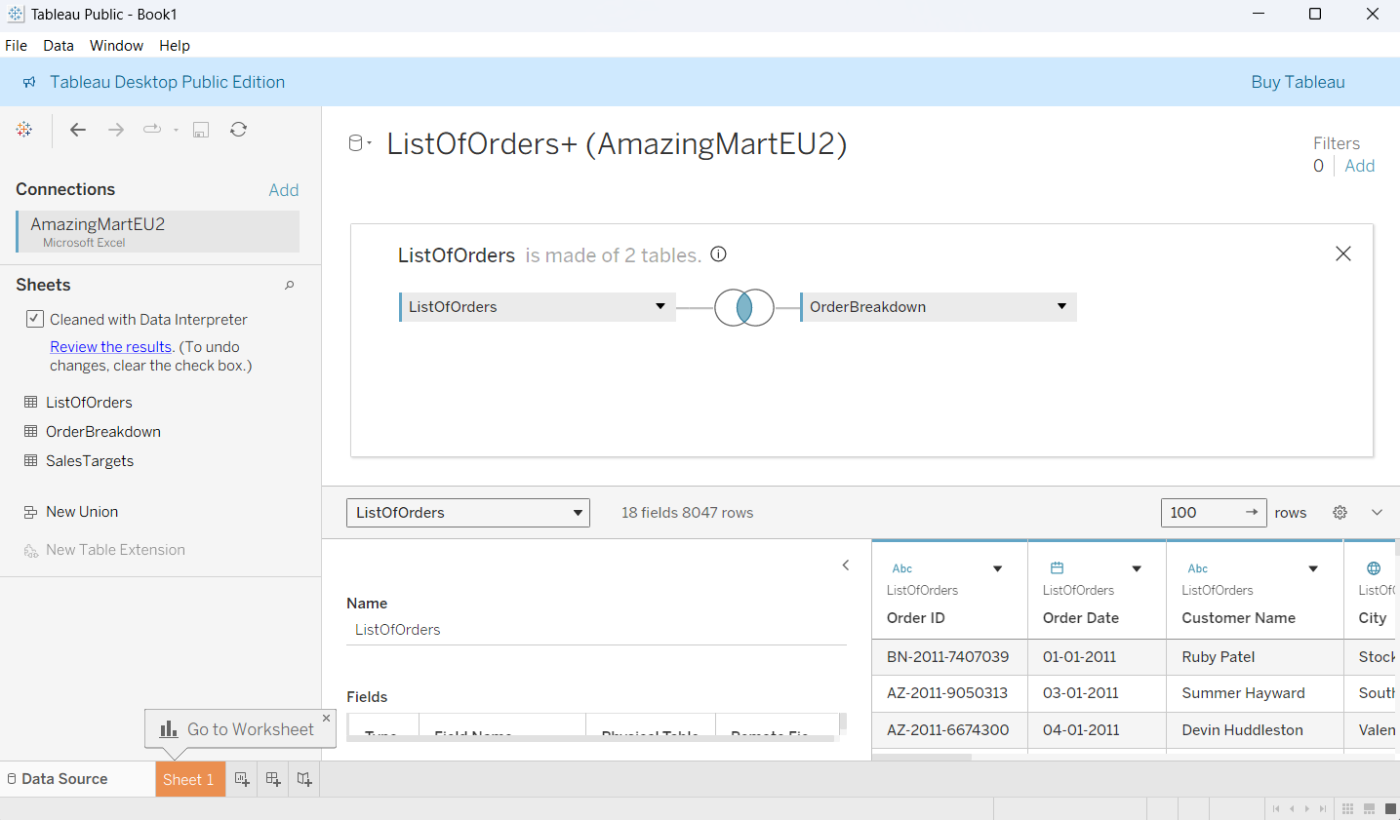

**CREATING BAR CHART WITH LABEL**

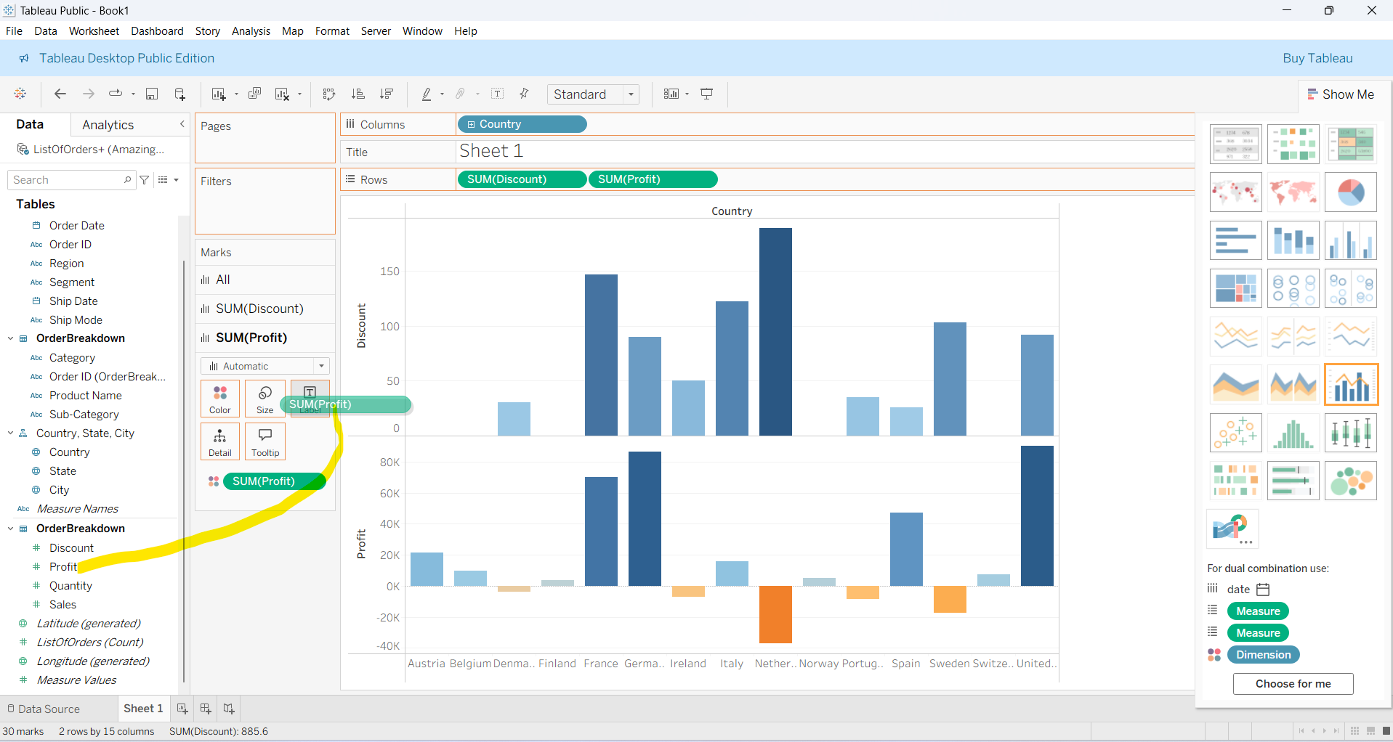

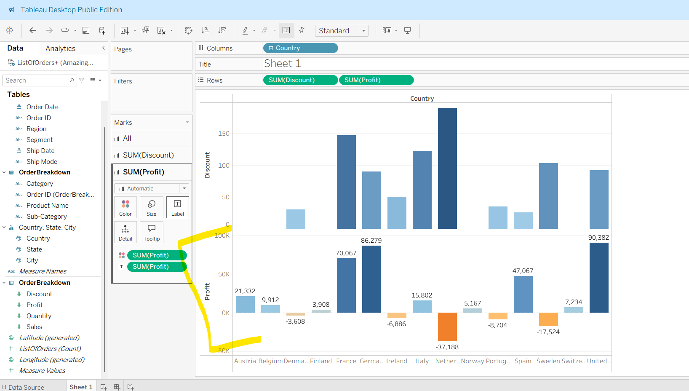

**CREATING DIFFERENT TYPES OF BAR CHART**

When we click on different charts in right side that will shows how many dimensional and measure will used for that particular chart. And also it tell dim should be placed where, measures should be placed where to get the output. See the below image, Since bar chart is good for independent categorical values, so try to give different category for dim

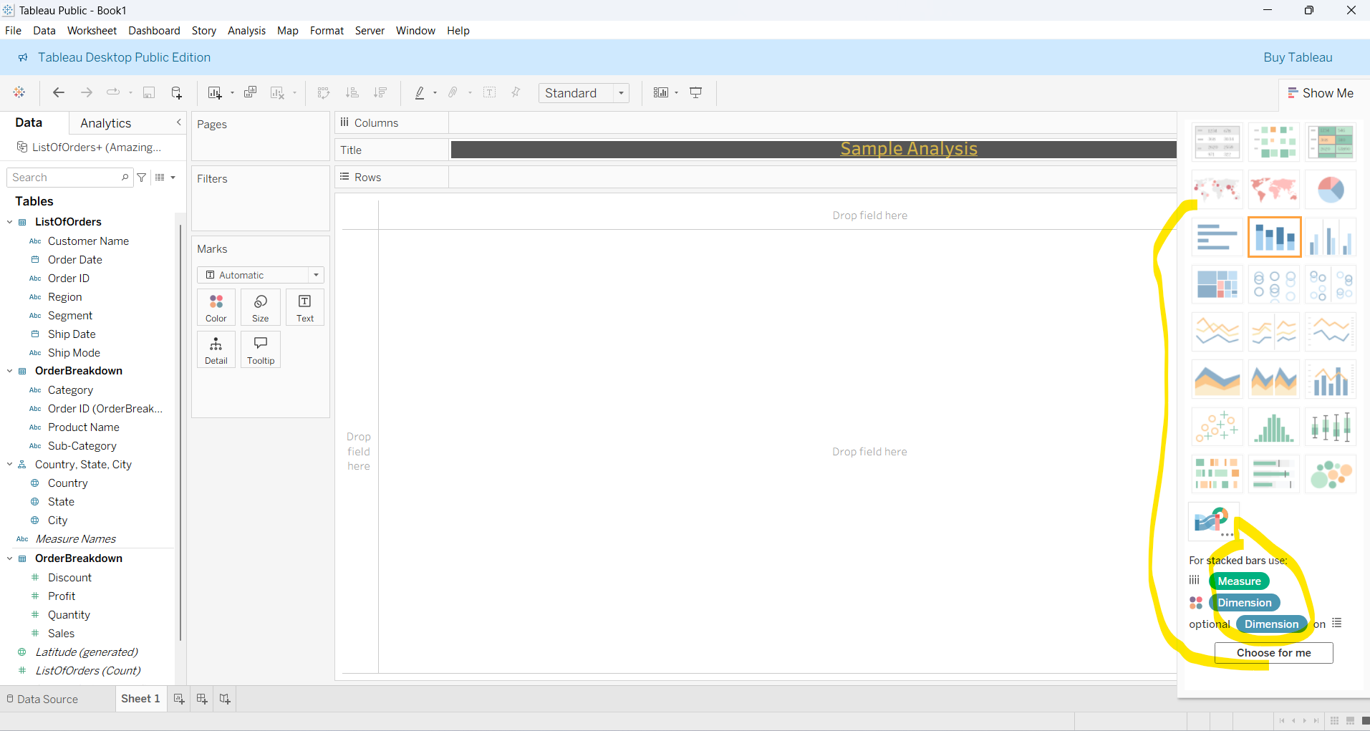

In above when we choose **choose for me** option tableau will chooses the dim and measures automatically like the below one.

**Sample chart**

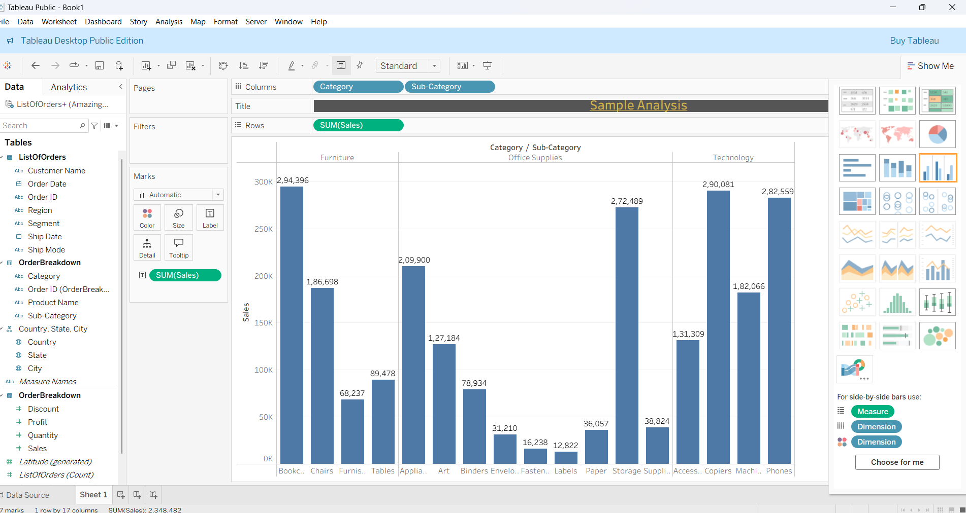

**NOTE:** Bar chart is good for independent categorical value, it cannot be used to represent negative values. For the line chart will be better

**ADDING DETAILS TO CHART**

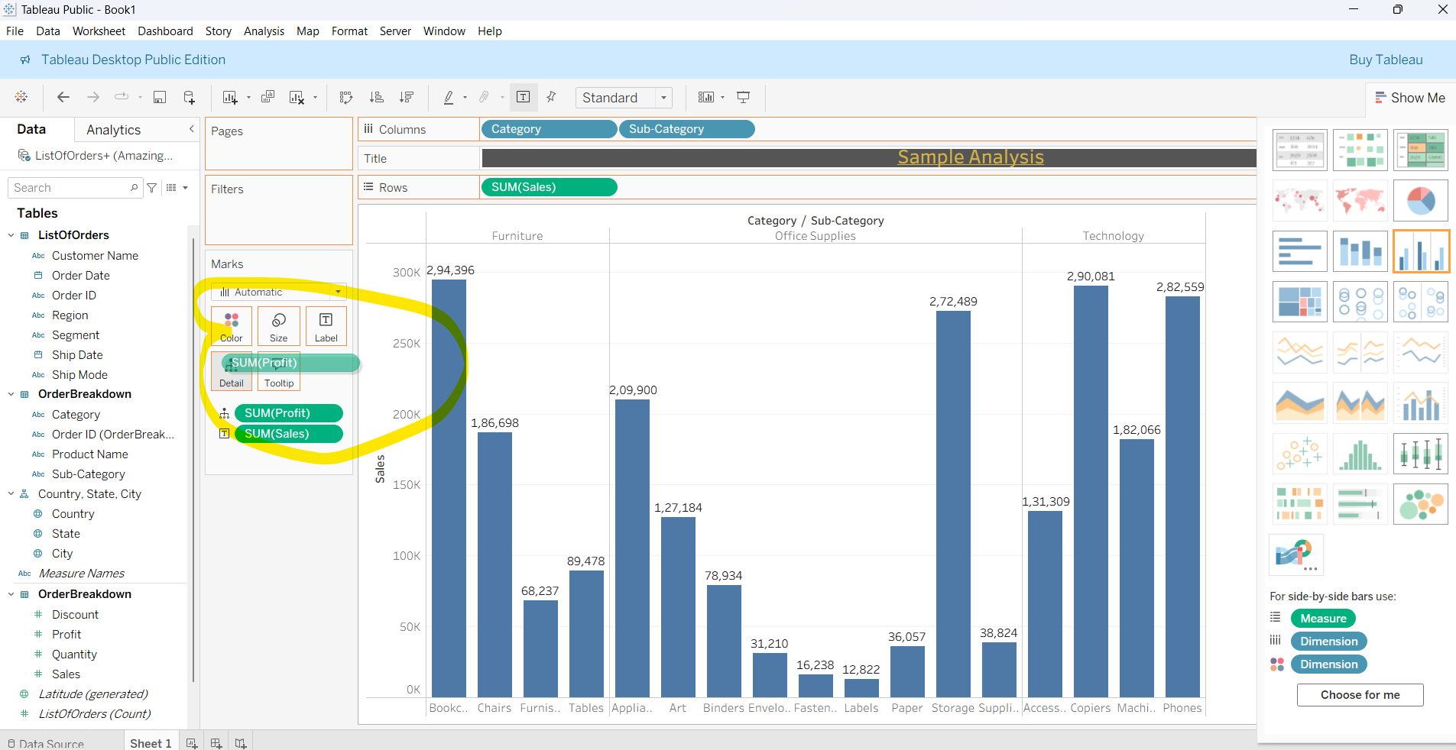

In above profit are added as details, that will be shown on tooltip when we hover like below

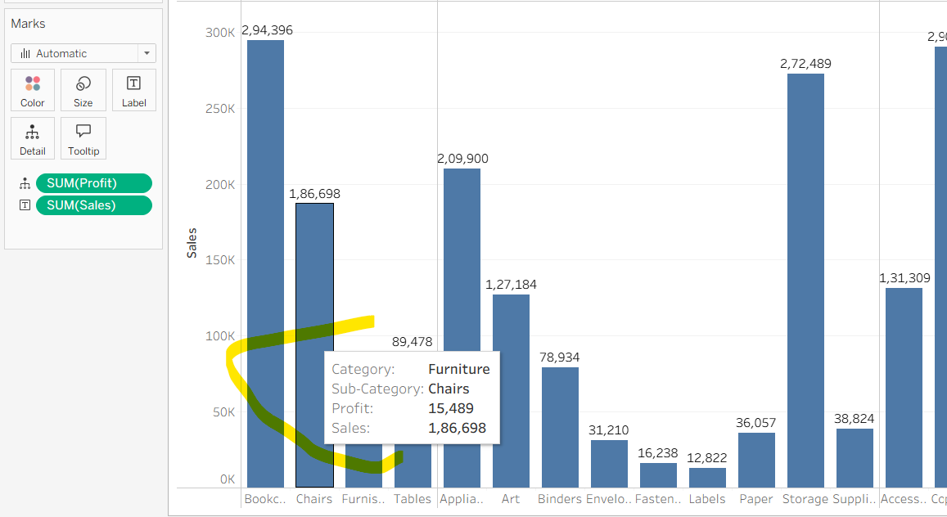

**LINE CHART**

Two types of line chart are available that is

A **continuous line chart** connects data points along a numeric or time scale (e.g., temperature over days).  
A **discrete line chart** connects data points for distinct categories (e.g., sales by product A, B, C).

✅ Example:

* Continuous → Day 1, Day 2, Day 3 → Temperature trend.
* Discrete → Product A, B, C → Sales comparison.

**EXPANDING DATE COLUMN**

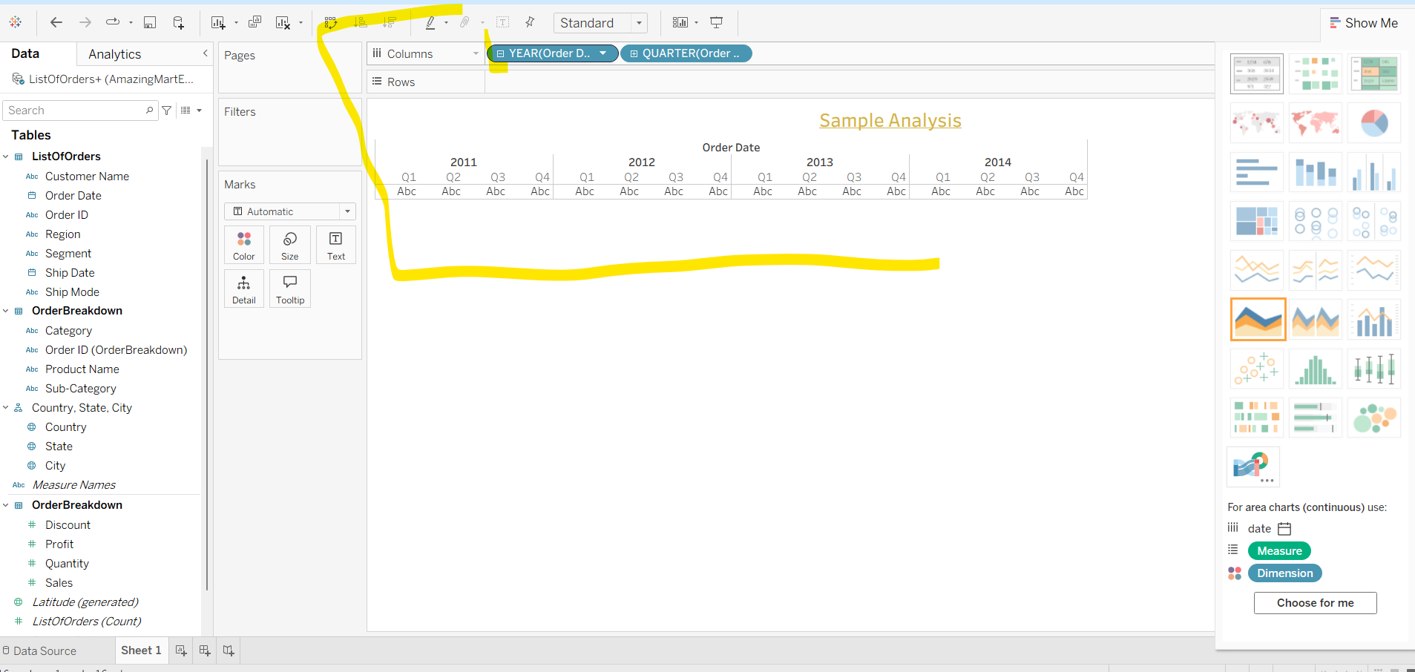

In above when we deal with date column in tableau by default it will show only year, by clicking the little plus icon in YEAR(Order Date) column there will be another sub category will be created from it called QUARTER

**CIRCLE PLOT**

According to our measurements it shows circles on that place in each dimension like below. There are two type of circle single circle(shows result with 0 dim), side be side circle (shows result with more the one dim).

Below example is for side by side circle.

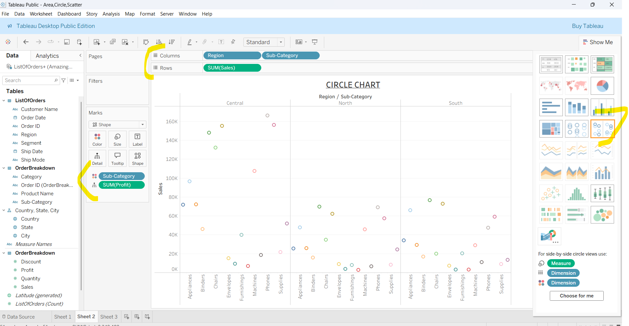

**Example for single circle**

Single circle will not take any dim for columns, it can takes dim for color.

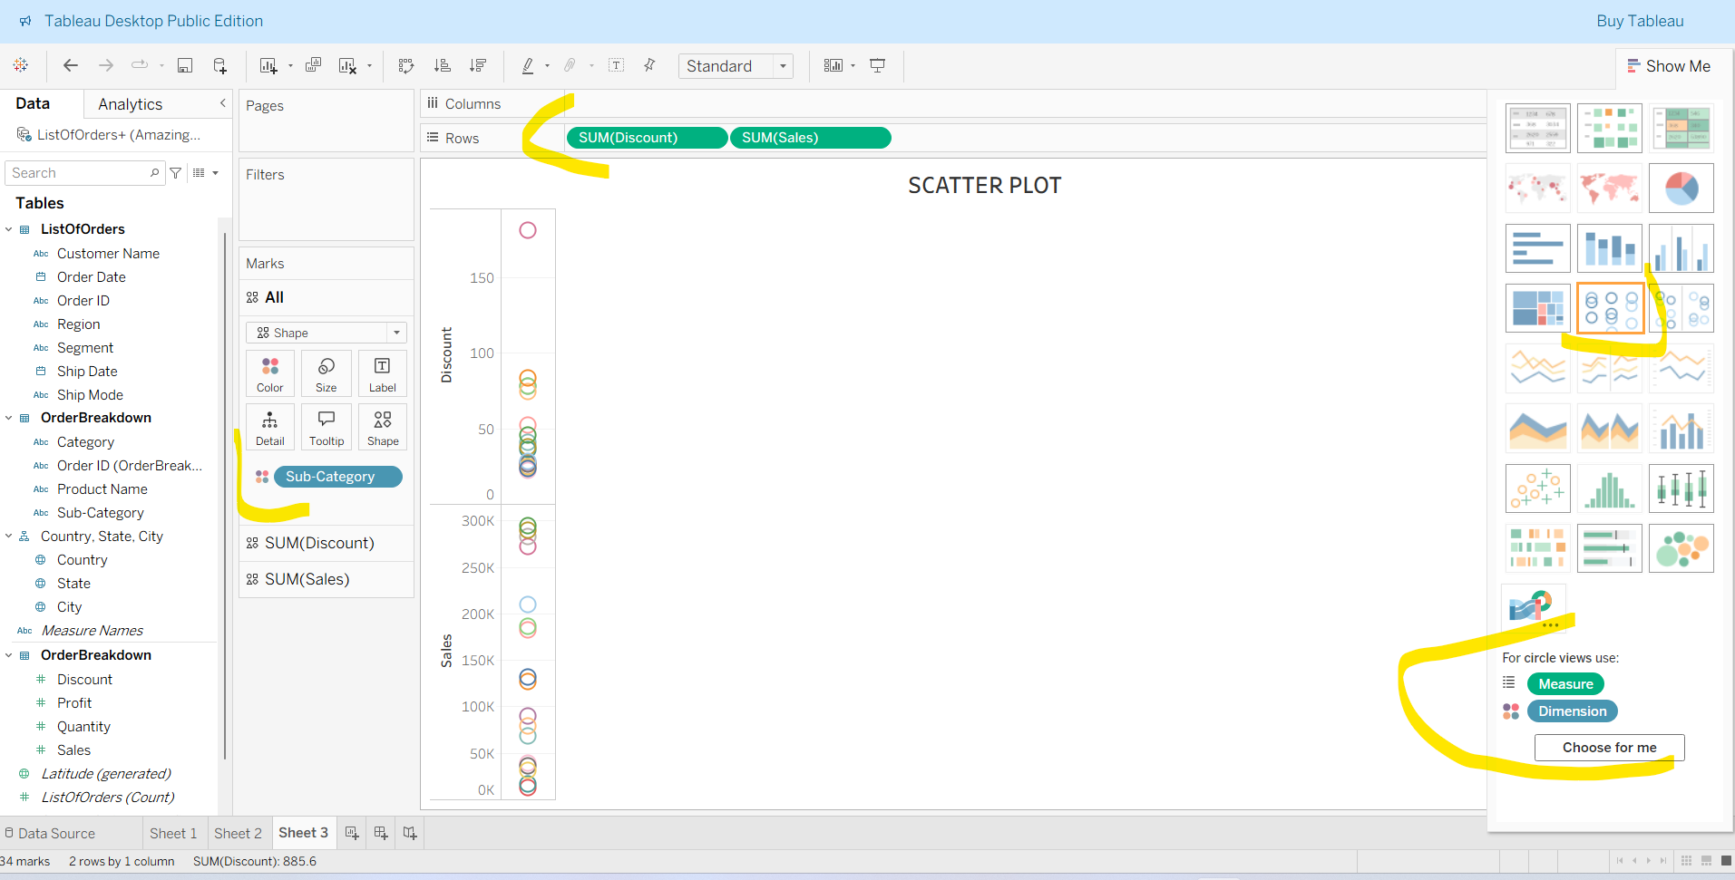

**SCATTER PLOT**

Needs two measurements and one dim for color like below, below will seems like circle but circle cannot hold measurements in each axis.

**Note:** When we select two measurements for scatter it will not work, because it take sum as default, so the scatter will be shown by the dim we are selecting for colors and details.

In the below example chosen color as sub category, so we can see if we increase the discount the sales is increased.

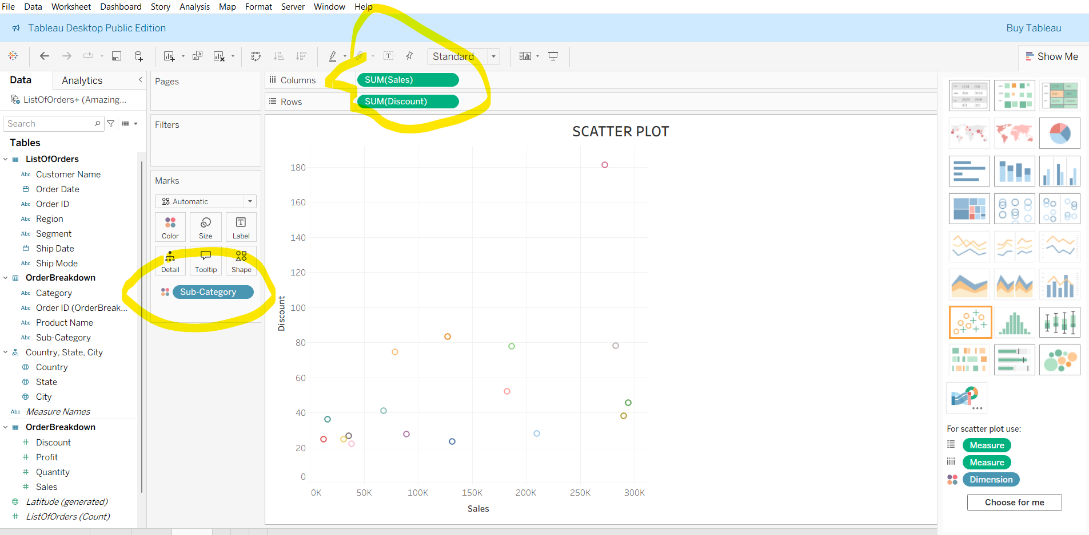

Without sub category the chart will look like below

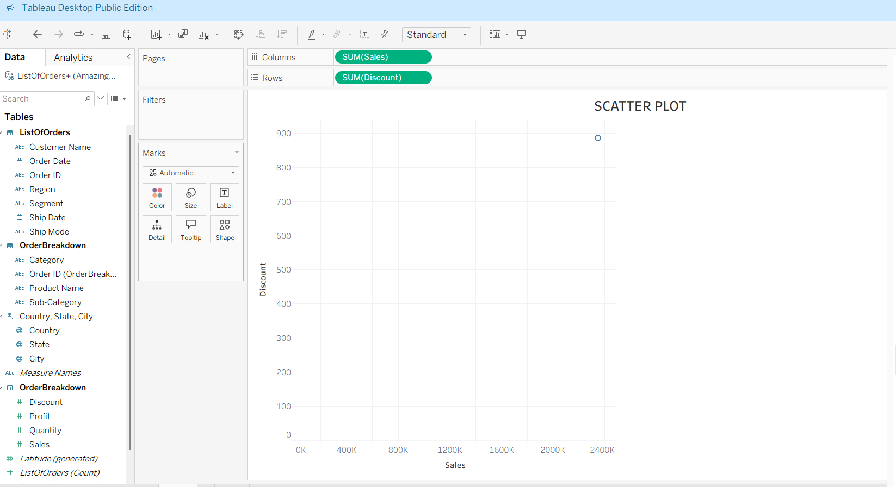

**HISTOGRAM**

It needs only one measurement, it is used when we want to see the counts of those each measurement range.

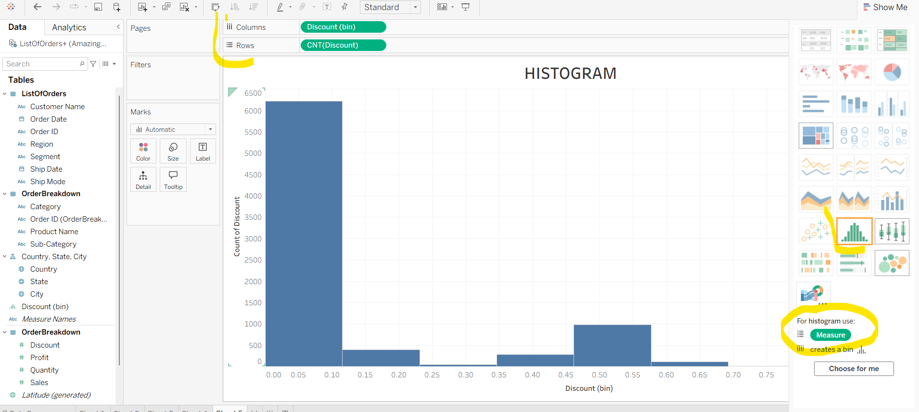

In above we chosen 1 measurement that is discount, so it gives count of discount range and bins are automatically created.

**TABLE HIGLIGHT IN TABLEAU**

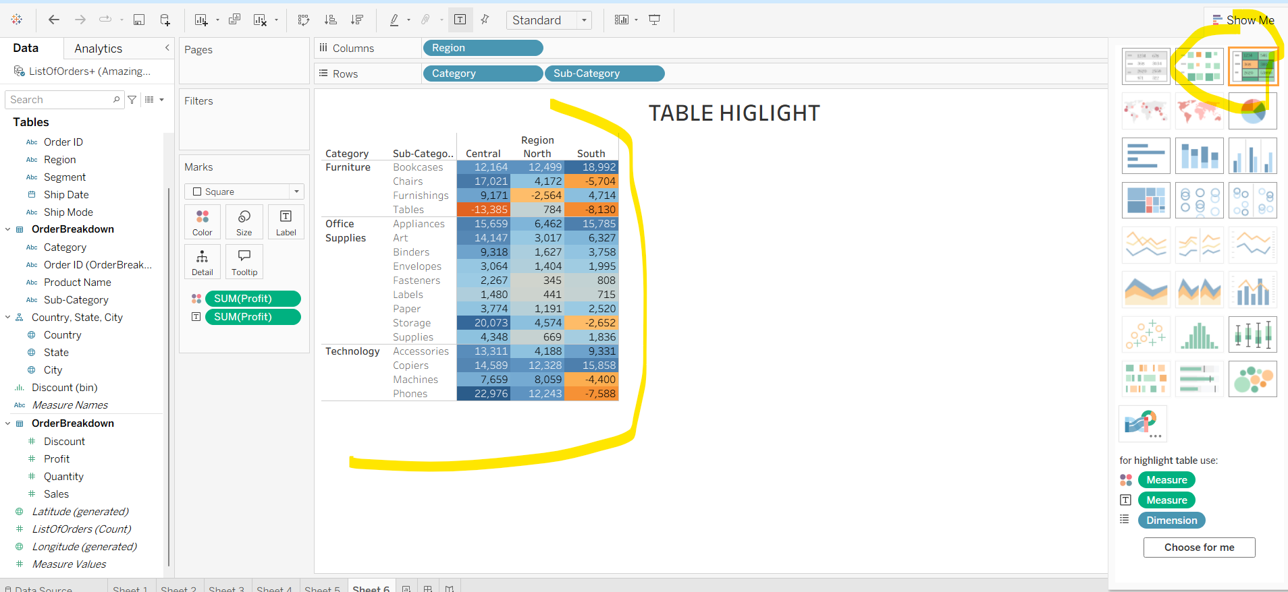

In above we chooses the field of profit and clicked the highlighted highlight table in right corner the whole table is highlighted with the value of profit.

**MAP**

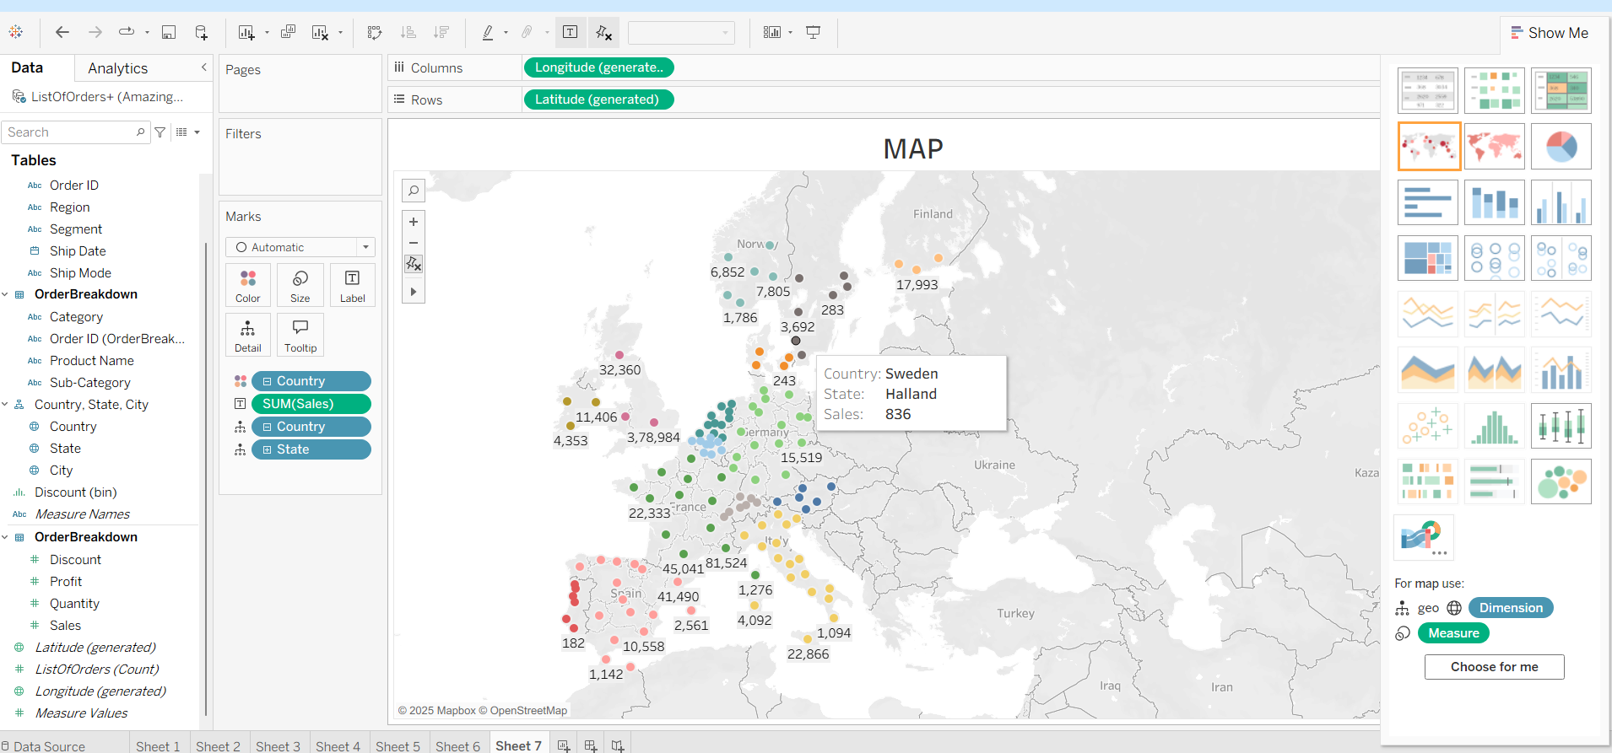

We can see the sales rate of different cities in each highlighted country

**APPLYING FILTERS**

In below we have countries which doesn’t obtain any bronze medals so we are going to eliminate those countries with the help of filter.

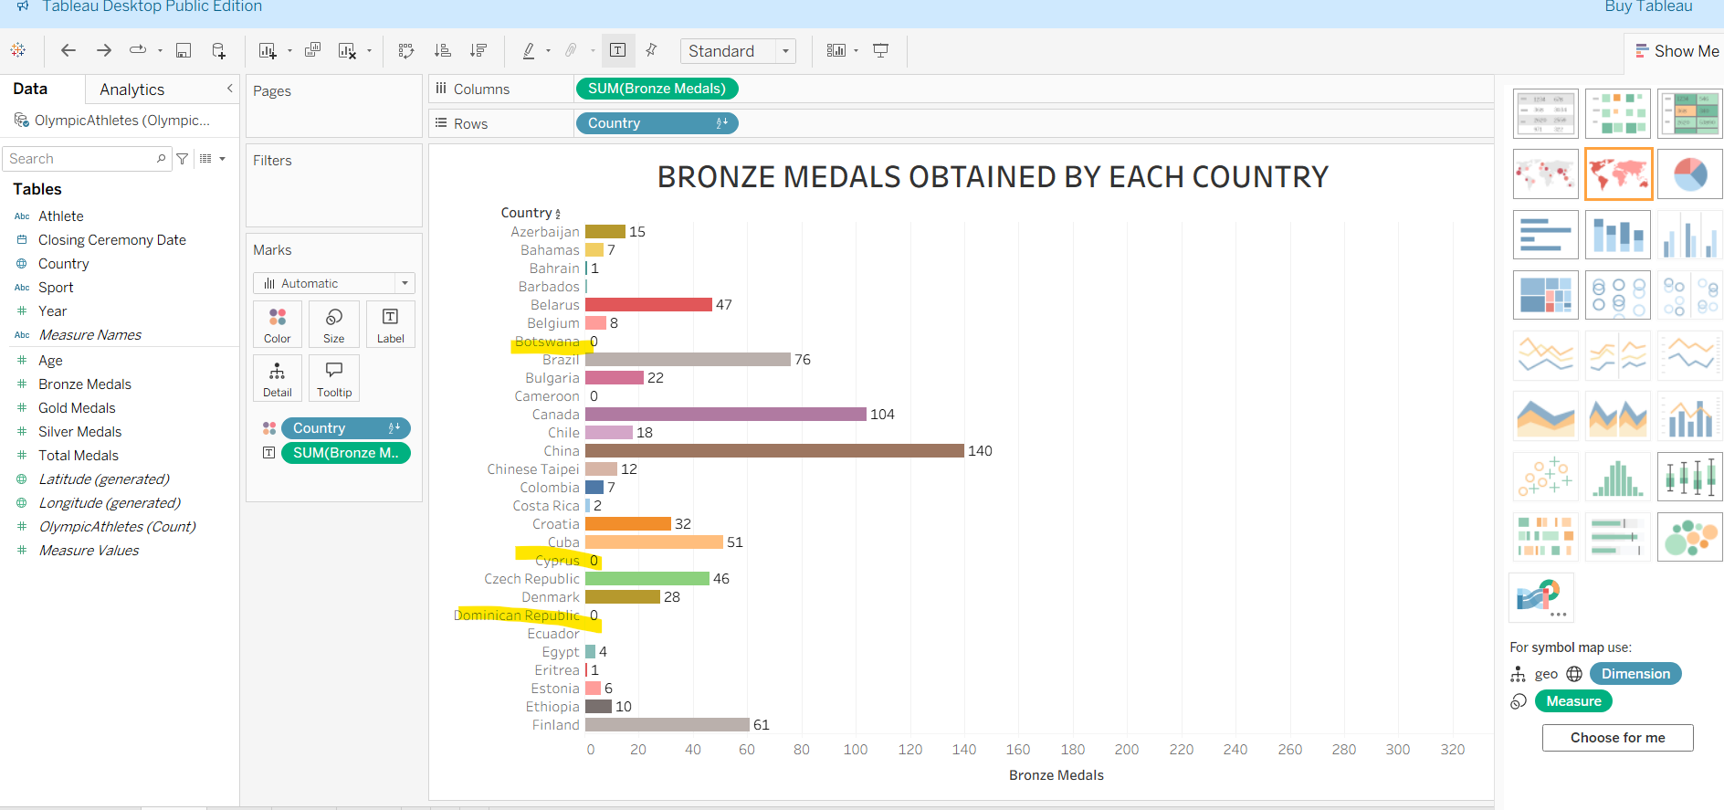

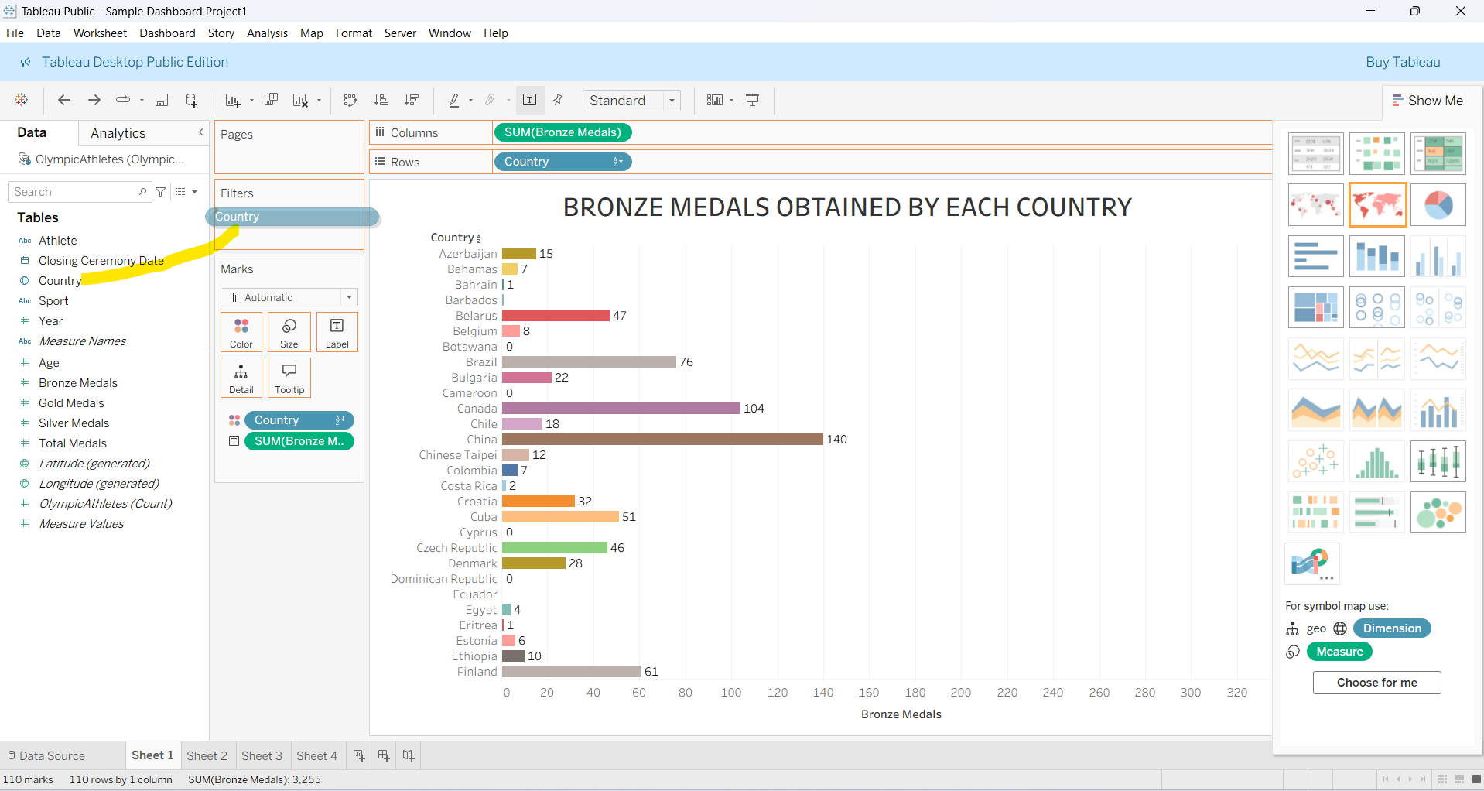

After drag and dropped the country to filter the below pop will be shown, form that go to condition. Apply the condition and now you can see the results after filter.

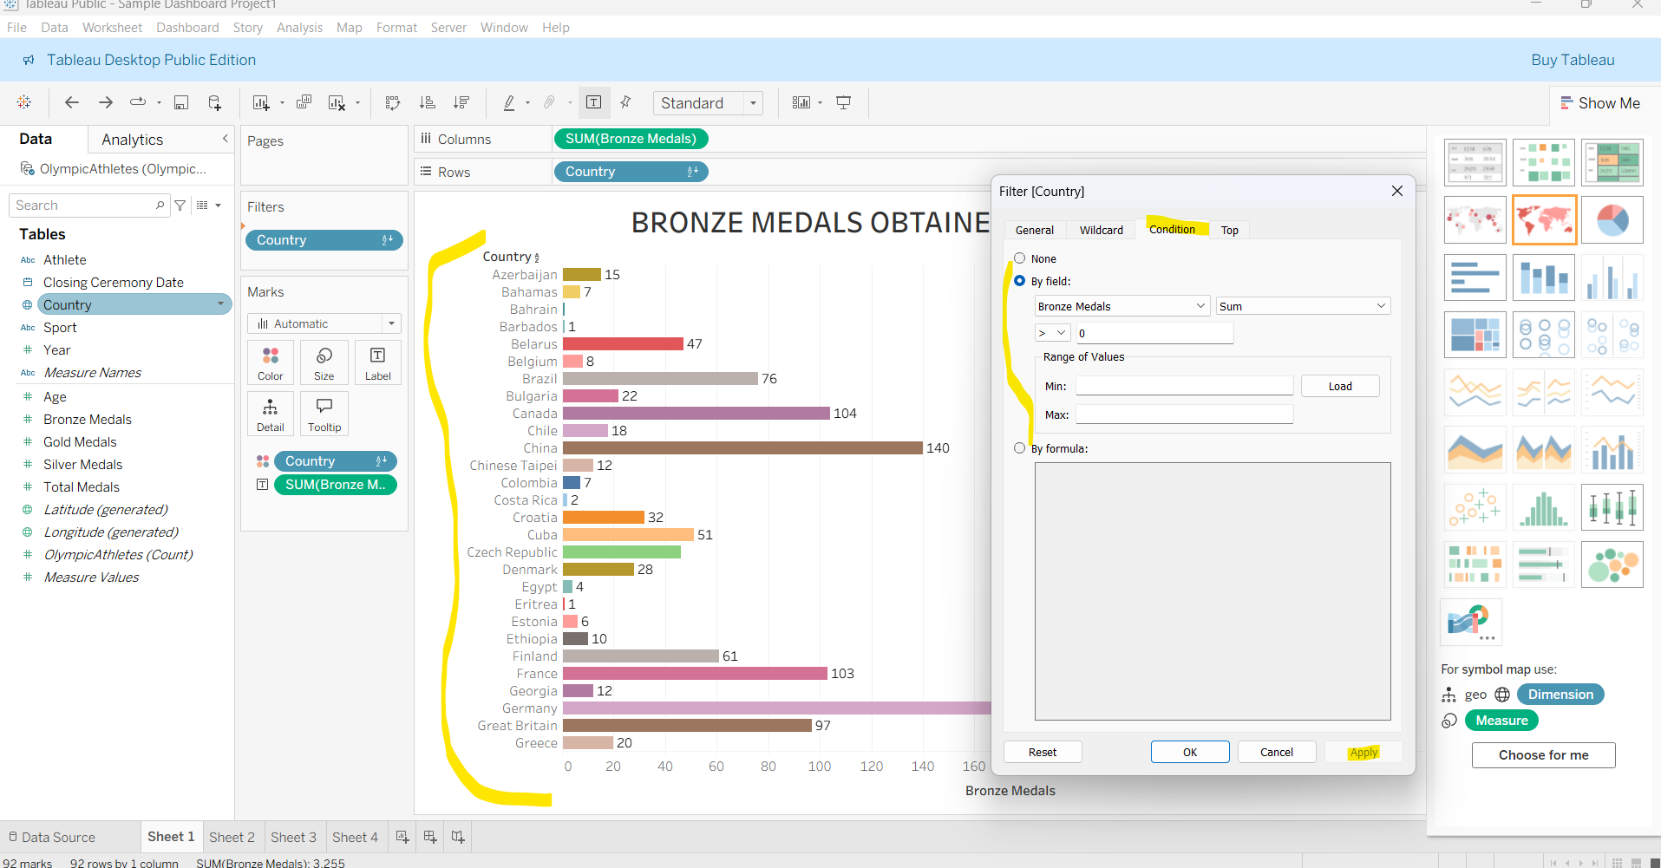

**TREE MAP CHART**

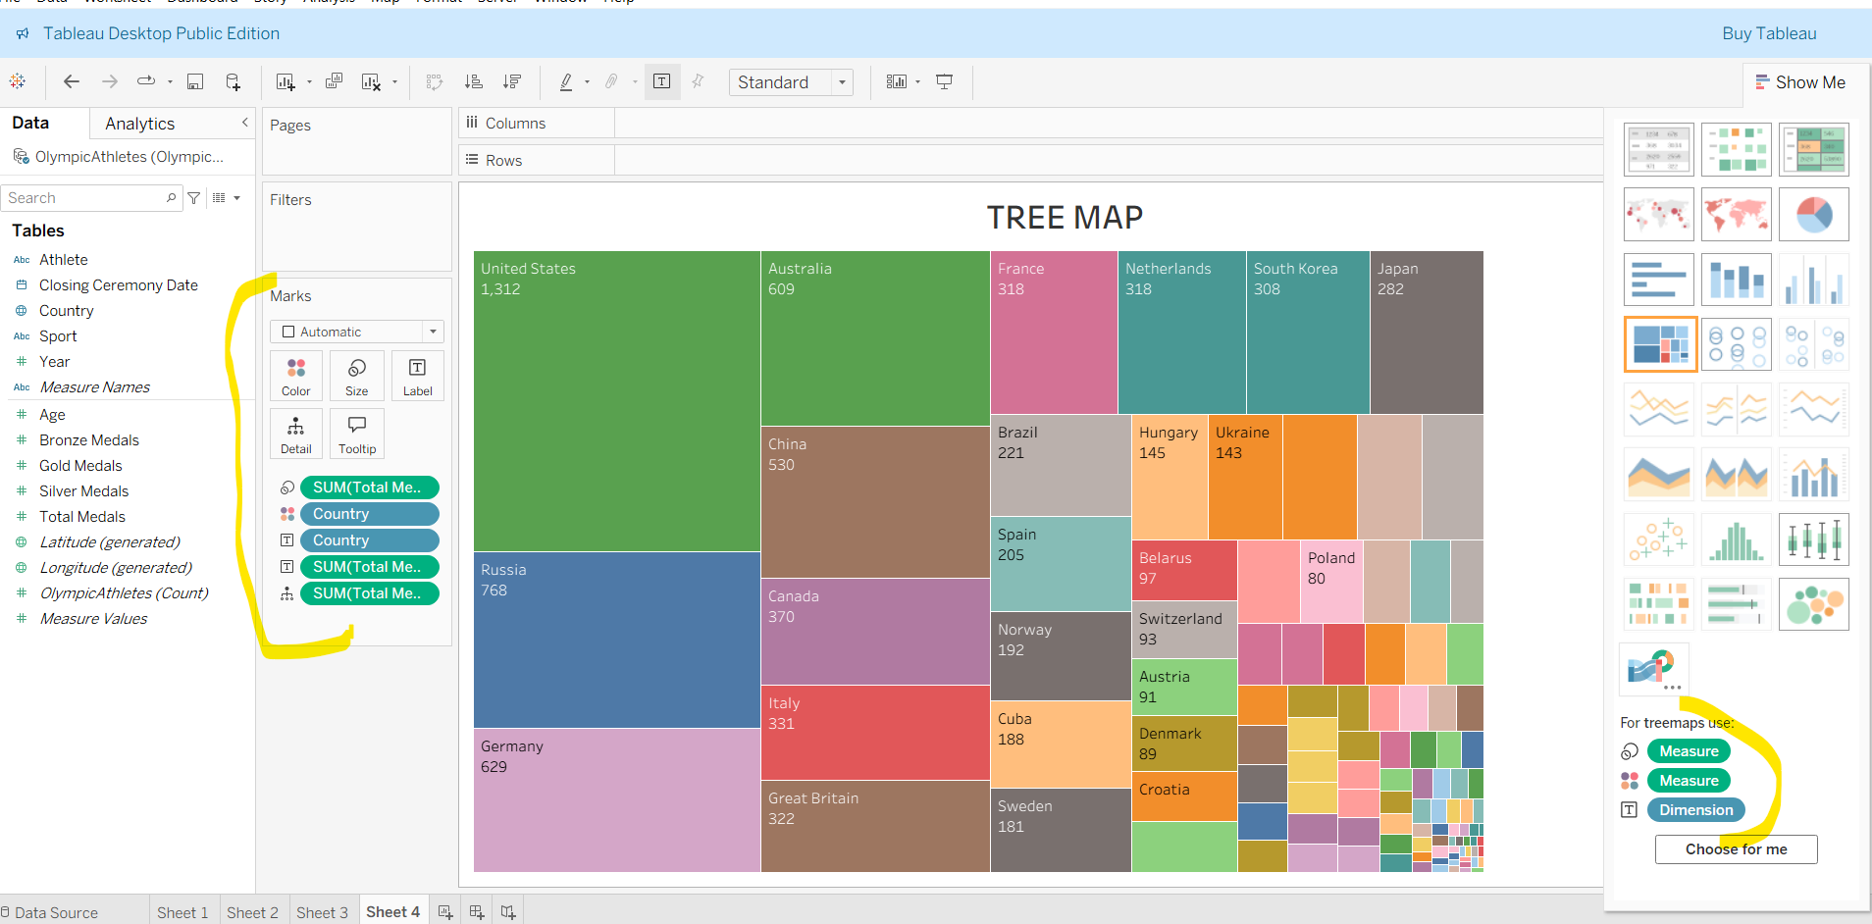

**DIFFERENCE BETWEEN BUBBLE CHART AND TREE MAP CHART**

Bubble is not good for hierarchy data like if we want to see how many medals obtained by each city in a state of country, here we have hierarchy like Country -> State -> City, so when we use this hierarchy view on bubble chart it will look mess like below.

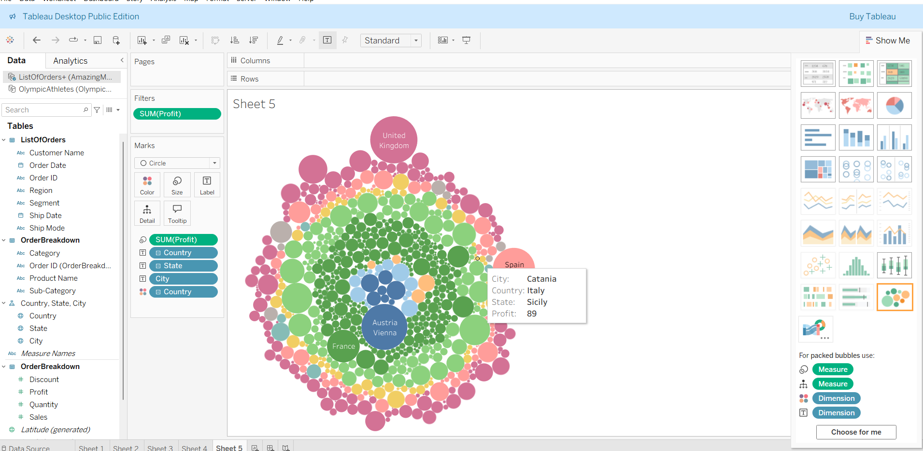

When we use this hierarchy on tree map it is good it see, it is not messy. In below chart each country is colored in different, and different size of boxes inside a whole box represents the city and state of the country, we got the clear view compared to bubble chart, but both will takes dim for color and size

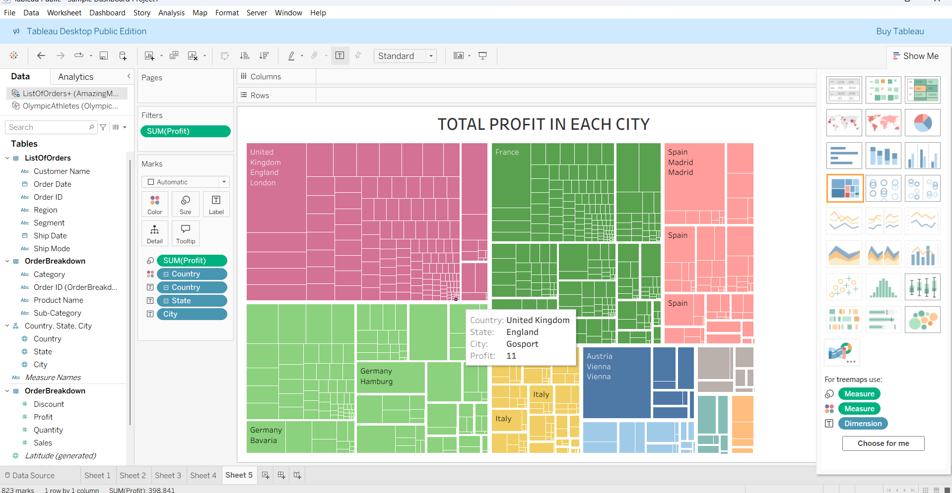

**CREATING DASHBOARD**

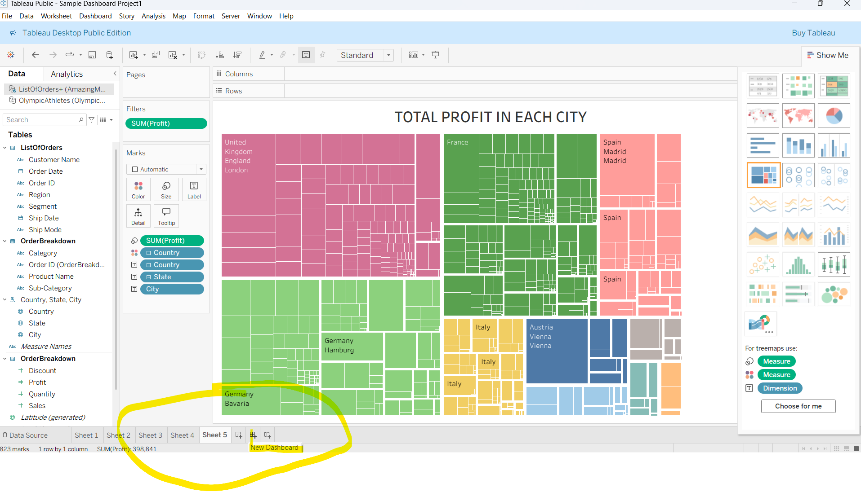

After clicking it you will got the below screen, on here you can just drag and drop all the shown charts on left side to the center of the screen like below.

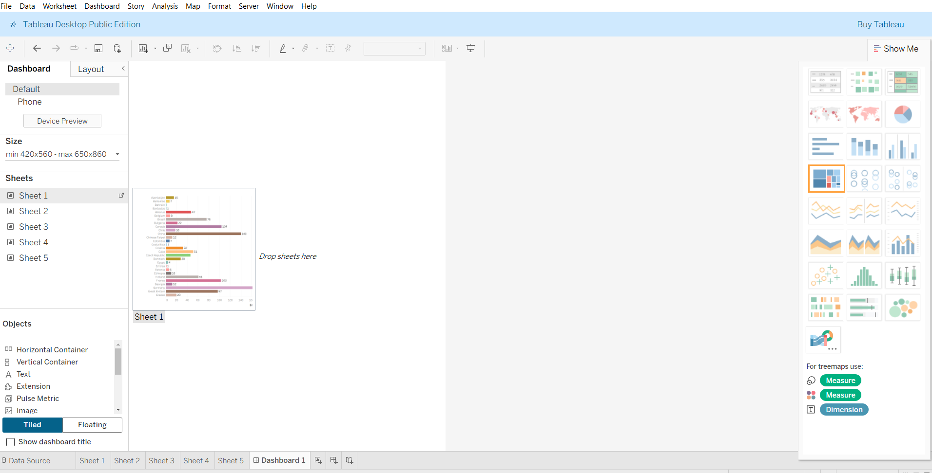

After putting all the charts in single dashboard it will look like below, when we click the particular legend that current values will be higlighlighted in all charts.

